- Read the 2 texts. Decide who is a freelancer and who is a full-time employee.

- “Hi, my name is Daniel, I am a Python developer. I have 2 years of experience. I like to work alone and develop projects from scratch. Usually, I work from home but sometimes I go to cafes to work. I find clients on Upwork and develop projects or some functionality for them. My rate is 20$/h. I have around 2-3 small projects each month. I like to have different types of projects and I like to have the freedom to choose what to develop.”

- “Hi, my name is Susan and I am a .NET developer. I have 4 years of experience. I work in a big team - we develop a very big web application. I like to spend time with my team and discuss project issues. Most of the time I work from the office but sometimes I can work from home. My salary is 3000$ a month, plus I have 20 days of vacation annually”.

2. Answer the questions about people from the text.

- Who makes more money per h of work?
- Who has more experience?
- Who has more projects?
- Who works from home more often?
- How many days of vacation does Susan have?

3. Match the word and the definition.
- Issue | - Money you get for one hour of work
2. Rate | d) Per year
3. Annually | b) Problem
4. From scratch | c) from the beginning
1.
2.
3.
4.

4. Look at the information from the Tech company's websites.

a) Decide what type of company it is. - Product or Service (Outsource)

1. “We deliver business and technology transformation from start to finish, using agile methodologies, proven customer collaboration frameworks, engineering excellence tools, hybrid teams* and our award-winning global delivery platform.”
*Hybrid team - part of the team works from the office and part remotely.
2. At ABC Company, we want to help people understand one another, whenever and wherever they communicate. Every day, 30 million people around the world use our product to strengthen their writing and say what they really mean.”

3. We are digital advisors and providers who operate at the cutting edge of technology. We deliver the innovation, quality, and speed that our clients’ users expect.

4. Our main purpose is to revolutionize the future of work for finance teams. Our technology changes the game by vastly improving the order-to-cash experience for finance teams and their customers with a smart and modern Accounts Receivable solution. We are at the forefront of back-office automation and machine learning.

5. We don’t just create world-class digital commerce experiences. From research and strategy to marketing and technical support, we forge long-lasting relationships with brands to help drive sustained growth. Together, we’ll design a commerce strategy unique to your business needs, uncover untapped revenue streams, and build an experience-driven ecosystem that ignites sales, delights consumers, and transforms casual buyers into brand champions. At every stage of our collaboration, we listen, learn, and react to help you grow your business.

b. Answer the questions.

- Which company develops financial solutions?
- Which company designs a commerce strategy?
- Which company has 30 mln users?
- Which company uses agile methodologies and mentions them?
c) Write down words and phrases that helped you indicate (guess) the type of a company.
Product company: ex. customer
Service company:
5. Read how people describe their company and guess the size of the company.
Company size? (big or small)
Sarah: In my company, I have different responsibilities, I manage the project and also test it. I have 10 people in my team and we really like working together”
Tim: In my company, I work as a developer. I really want to become a senior developer in this company. I like everything except a lot of paperwork and a long approval process.
James: I like that my company is developing and I can suggest improvements and changes to its strategy. Everything is great but it would be great to have more benefits!
Think about what type of company would be perfect for you. Big, small or middle-sized? Why?

6. My friend Sarah has a new job. I want to find out more about her new company.
I will send her a message with some questions). Help me complete the questions with missing words).
What …. the type of your new company, service or product?
How ……people work there?
When …… this company founded?
Where …..the main office of your company?
Who ……. the CEO* of your company?
CEO* - A chief executive officer (CEO), the main manager in the company.

7. What question word do we need to use if we want to find out about:
1) The person?
2) The location
3) The time?
4) The object?
5) The number of something?
8. Yesterday, Sarah sent me a message with her answers to my questions. Read her message.
Hi, Kate
Thanks for your letter.
I always wanted to work in a product company and now my dream has finally come true! I am so excited!
So my company is pretty big, now there are around 800 employees. The company was founded in 2009. Our main office is in San Francisco, California. I really want to visit this office someday and meet our CEO, Brad Hoover.
And what about you, Kate? How are you doing?

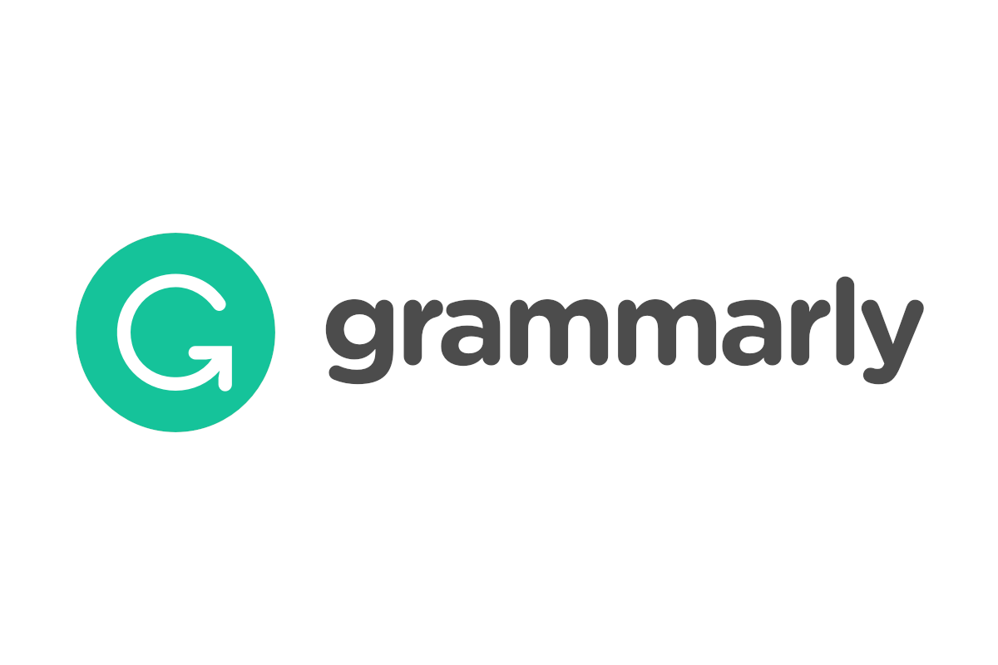
9. Sarah sent her answers but I still don’t know the company's name.
I have 2 suggestions (option) Help me choose the company Sarah is working for).
 | 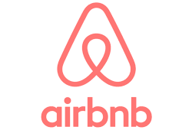
Max Lytvyn, Alex Shevchenko, and Dmytro Lider founded Grammarly in 2009 with the goal of helping people communicate more effectively. The software is produced by Grammarly Inc, which is headquartered in San Francisco, California. | Airbnb, Inc. is an American company that operates an online marketplace for vacation rentals and tourism activities. Based in San Francisco, California, run by CEO Brian Chesky. Founded in 2008 and now has over 6000 employees.
(Yes, you are right, it is Grammarly).

Additional task!
10. Put words in these questions in the correct order. Answer the questions about your future company.

What, we, make, product, do ?
Who, product, our, use, can ?
start, do, we, work, When?
we, need, office, Do, an ?
How, need, many, do, employees, we?
What, technologies, do, use, we?
Where, we, have, our, office, do?

ex. What product do we make?

